Day 8 Lab Answers
(Restaurant Management system)

Task 1
Quantity vs Available Dishes
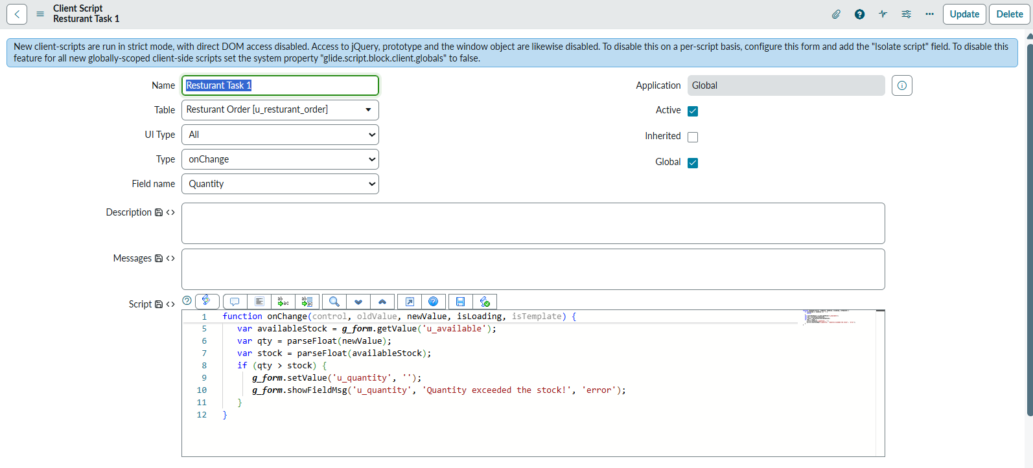

Task 2
Auto-Set Cuisine Type
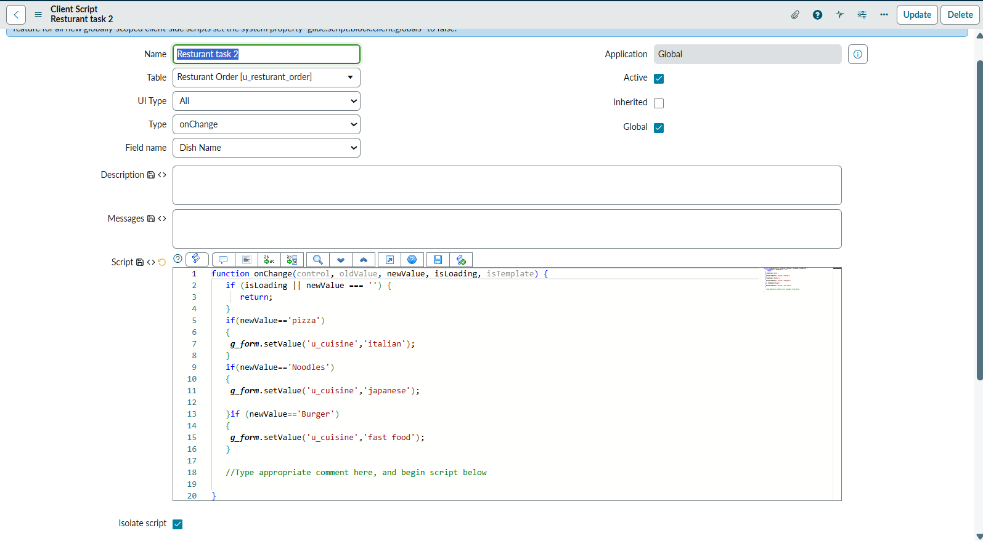

Task 3
Show/Hide “Spice Level”
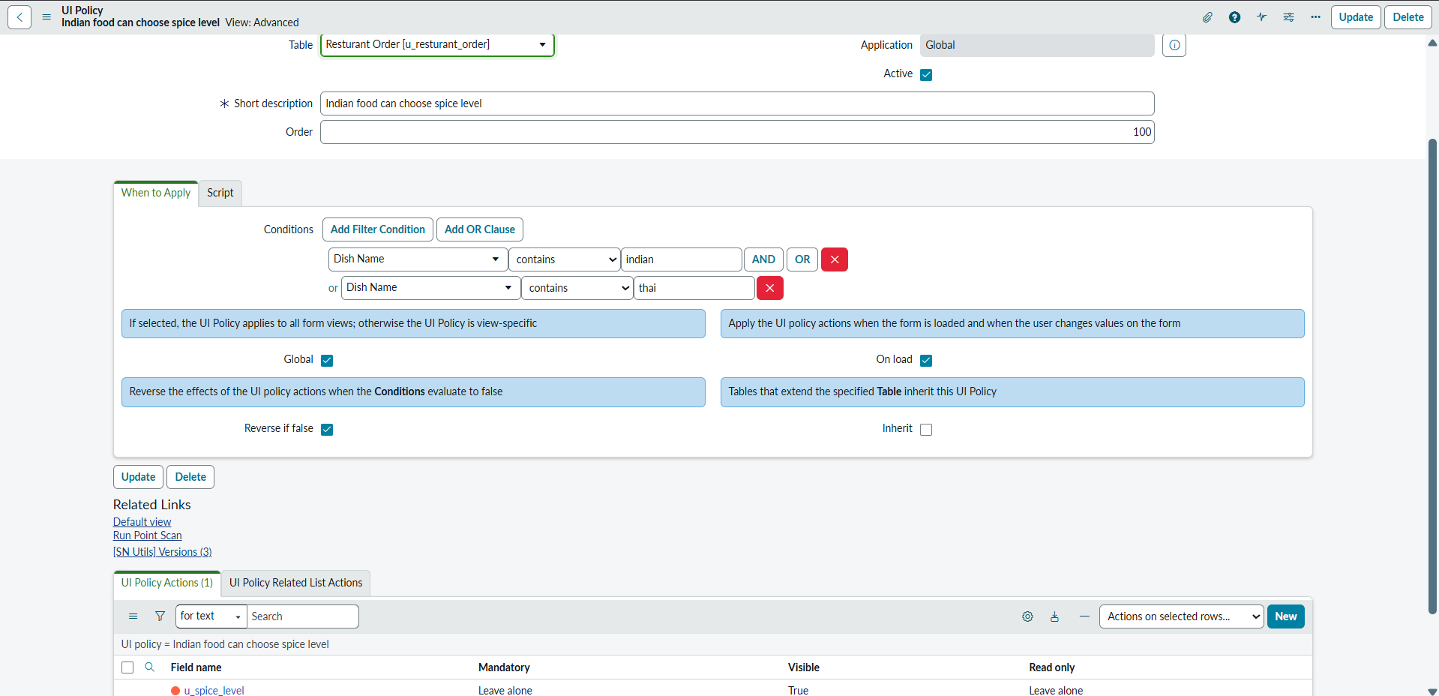

Task 4
Prevent Invalid Order Submission
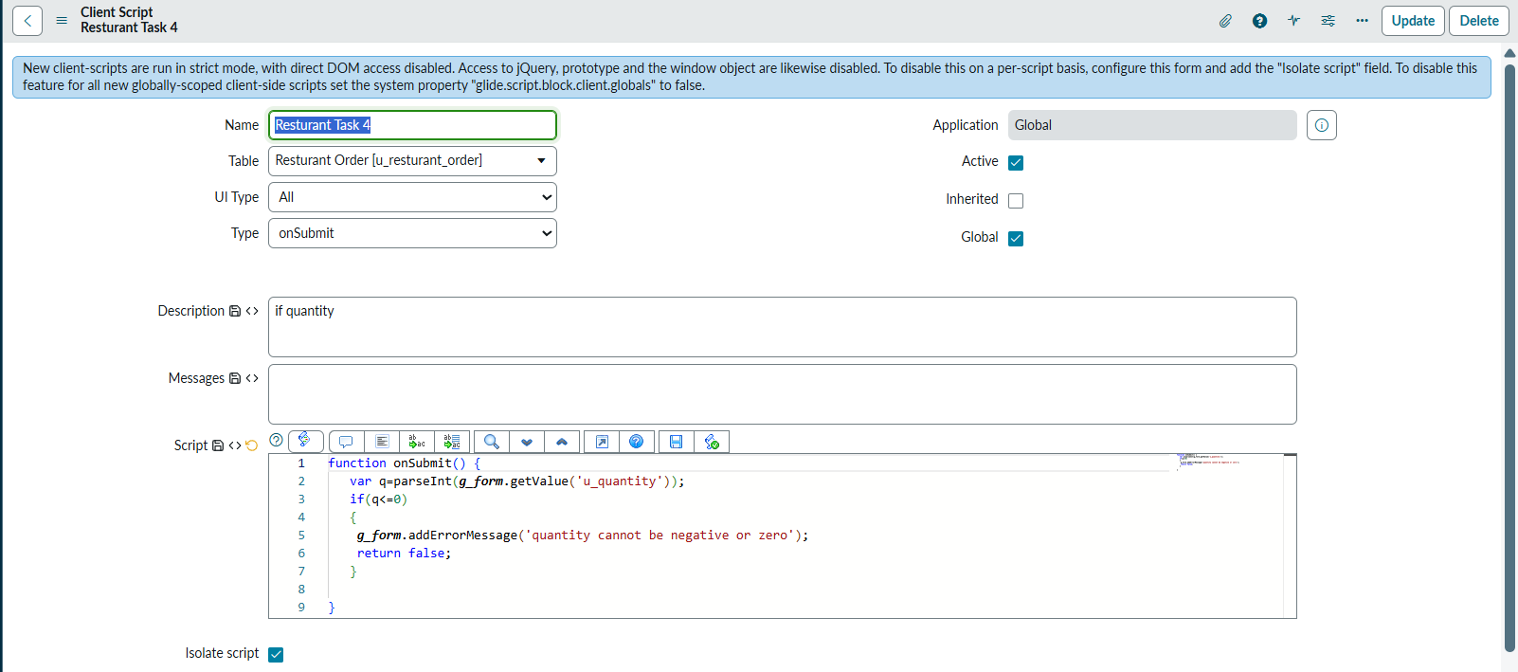

Task 5
Auto Calculate Total Price
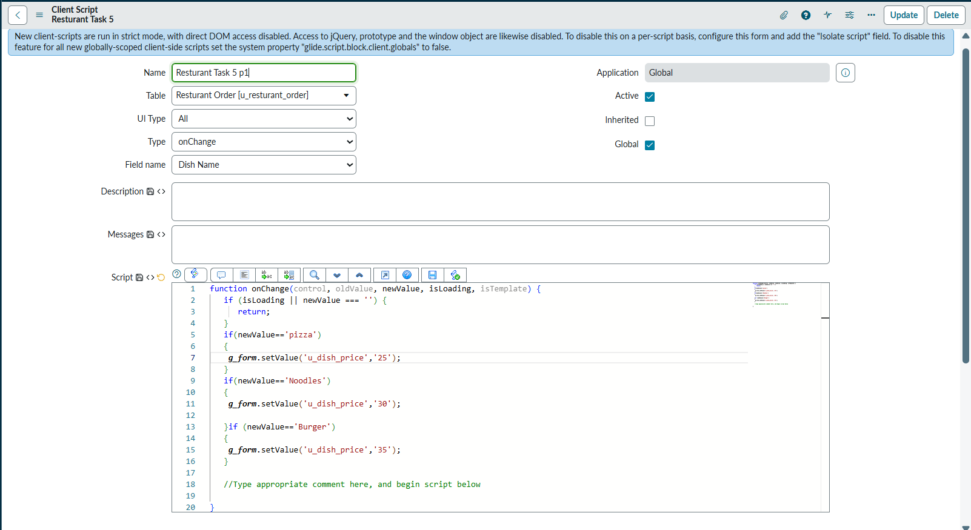

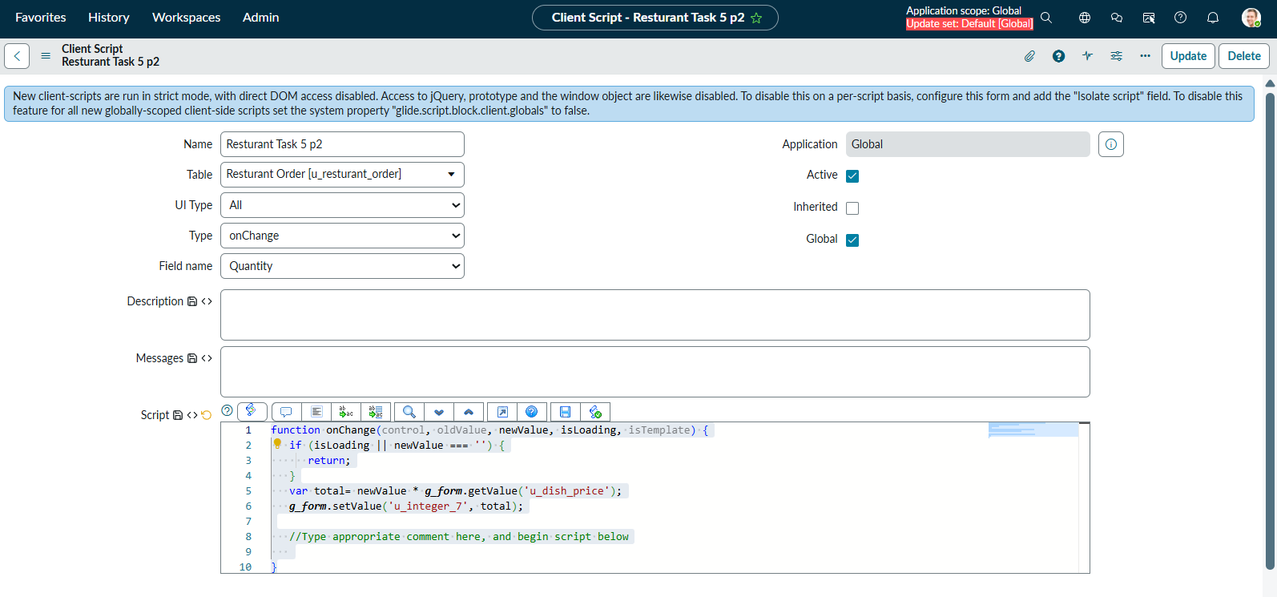

Task 6
Prevent Ordering Same Dish Twice

Task 7
Limit Maximum Items per Order

Task 8
Delivery Type Controls Fields

